Performer information, FAAM Airborne Laboratory

Row 3 (1) Please provide a detailed description of system configuration and primary components including the sensor and deployment platform. Additionally, the location (latitude, longitude, height) of auxiliary components such as meteorological station or any other equipment installed at or near the Test Center must be recorded.

The deployed platform is an instrumented BAE-146 research aircraft. Its position data (latitude, longitude, altitude, ground speed, heading) are provided by a GPS-aided inertial navigation system (GIN). A full description of the meteorological measurements’ capability (temperature, humidity, winds) is provided in Price, 2022 (https://zenodo.org/doi/10.5281/zenodo.5846961).
Gas-phase in-situ chemistry measurements are conducted for greenhouse gases (CO₂, CH₄ and H₂O) using a customised Los Gatos Research Inc. Fast Greenhouse Gas Analyser (model 907-011-000-000), based on the laser absorption off-axis integrated cavity output spectroscopy technique. The methods for 1 Hz measurement, initially flown in 2011, are described in O’Shea et al. (2013). The FGGA system was subsequently upgraded in 2019 and 2021 to measure gas mole fractions in dry air at 10 Hz (Shaw et al., 2022). The 1-sigma overall uncertainties based on in-flight calibrations are ± 0.67 ppm for CO₂ and ± 3.7 ppb for CH₄. Measurements are traceable to the World Meteorological Organisation greenhouse gases scales WMO-CO₂-X2019 and WMO-CH₄-X2004A. The FGGA inlet lag time is 175±46 ms, and the instrument e-fold flush time is 140±46 ms.
Carbon monoxide mole fractions are measured at 1 Hz by an Aero-Laser GmbH VUV resonance fluorescence spectrometer (model AL5005). This instrument shares the same inlet and calibration system as the FGGA. Measurements are traceable to the World Meteorological Organisation greenhouse gases scale WMO-CO-X2014A.
Ozone mole fractions are measured every 2 secs with a 2B Technologies Inc. dual beam UV absorption photometer (see full description of model 205).
Nitrogen oxides (NO and NO₂) are measured at 10 Hz by a fast dual channel chemiluminescence analyser developed collaboratively with NOAA and Air Quality Design Inc. Two detector channels operate in parallel and share a common pressure-controlled inlet allowing for parallel calibration. The inlet design follows a bypass design similar to that described in Pollack et al. (2010). A chemiluminescent zero is taken every ~5 min by increasing the NO + O₃ reaction time as in Drummond et al. (1985) in 240 mL PFA Teflon zero volumes. The chemiluminescence reaction volumes are temperature controlled and follow the 241 mL gold plated design of Ridley et al. (1990). To mitigate sensitivity drift due to chemiluminescence quenching by water, the reagent ozone is humidified to 2-3% as in Ridley et al. (1990).
Sulphur dioxide mole fractions are measured at 1 Hz using a customised Thermo Fisher Scientific pulsed UV fluorescence analyser (see full description of model TEi43i TLE).
Discreet ethane and other non-methane hydrocarbons are measured off-line by collaborators at the University of York, Wolfson Atmospheric Chemistry Laboratories. GC-FID/MS analysis was performed on 80 pressurised stainless steel canisters collected during the mission (sWAS system).
Discreet δ¹³C_{CH4} (¹³C:¹²C stable CH₄ isotopes ratio) are measured off-line by collaborators at the Royal Holloway University of London, Earth Sciences Department’s Greenhouse Gas Laboratory. Methane isotopic analysis by GC-Continuous Flow-Mass Spectrometry was performed on 18 Tedlar bags collected during the mission.

Gas-phase chemistry measurements are further complemented by aerosol number concentrations provided by a Passive Cavity Aerosol Spectrometer Probe (PCASP) with SPP-200 electronics, operated in a wing-mounted canister. This instrument provides aggregated 10 Hz particle numbers in 30 size bins across a nominal diameter range of 0.1–3 µm. The smallest bin is discarded due to an undefined lower boundary, and bins are merged at the gain-stage crossover points as described by Ryder et al. (2013). Particles are binned according to the strength of the photovoltage generated by the HeNe laser light scattered by each particle. Laboratory calibrations both before and after the campaign are used to convert photovoltages into scattering cross-sections for each bin (Rosenberg et al., 2012). These calibrations are provided in separate files alongside the data files to be applied by the data user. With knowledge of the aerosols being sampled, the scattering cross-sections can be converted into particle diameters. This information must be determined through other means and applied by the users to obtain calibrated particle sizes and thus size distributions and any required derived parameters. The volumetric flow rate, which is used to calculate particle concentrations, is calibrated in the laboratory using a Gilibrator 3 (Sensidyne, LP) dry-cell calibrator.

Row 7 (5) Please provide a detailed description of the methodology used during emission detection/quantification surveys.

Emission detection methodology

We designed our flight plan on the basis of the Gauss’s theorem cylinder described in Conley et al. 2017. Although this methodology is more suited for spatial scales of ~1 km, we flew 2 NM (3.7 km) radius orbits around the TADI site to maximise the number of plume interceptions over the 45 minutes-controlled release period. Our most commonly flown survey methodology (mass balance), consisting of repeated crosswind transect downwind of our target, was deemed too difficult due to air space restrictions within the prohibited area LF-P04, and low-level 500 feet flying constraints above ground level.

The first step of our methodology is plume detection during each orbit. All aircraft data sets were merged to a common 10 Hz time base, with chemistry measurements timestamps corrected for time lags. Multiple plumes were detected from sources originating within and around the IndusLacq complex, including the A64/E80 motorway, some from combustion sources based on chemical markers such as NO_{x}, CO₂, SO₂ and aerosols (PCASP). Several Matlab-generated plots of the geographical extent of these plumes detection during orbits, and their chemical fingerprint, are provided in the participant’s supporting information. It is worth noting that we are still investigating the impact from our aircraft exhaust advecting in the task area during orbits, and potentially compromising the validity of our measurements. This includes the analysis of a previous test-flight survey conducted around North Sea off-shore gas platforms on 17 June 2024, before our TADI mission of 12 September 2024.
For previous offshore missions, FAAM has successfully identified and integrated plume enhancements using an automated Python script analysing the variance of an upwind baseline, and detecting the downwind divergence above multiple standard deviations. However given the complex nature of having to deconvolute multiple plumes with differing baselines, it was not possible to adapt our Python script within the brief time available for this Stage 1 data analysis turnaround. We assume a single CH₄-only point source from the controlled release, and CH₄ plume start/stop times were therefore defined manually for each orbit, based on the absence of combustion chemical tracers and aerosols.
Due to the limited time available for the Stage 1 data analysis, we only report here results for controlled release #7. Plumes for controlled releases #6 and #8 were detected, albeit with much lower CH₄ enhancements due to the much wider spatial extent of our orbital surveys (wider radius outside of LF-P04). We will nevertheless endeavour to analyse observations during these two other releases and quantify them during our Stage 2 analysis.
Each orbit CH₄ plume enhancements were then integrated to obtain ppb.s values using a Python script, and scaled to ppb.m using the mean aircraft ground speed measured by GIN (112±3 m/s). An example time series for a CH₄ plume detected between 14:31:18.8 and 14:31:32.0 UTC is provided in the participant’s supporting information.
Tabulated values for Observed Integrated CH₄ Enhancements [ppb.m] are provided in the participant’s supporting information.
We now consider the impact of the low wind speeds (2.12±0.8 m/s mean, less than our stated minimum 5 m/s threshold requirement) and local meteorology experienced during our survey. We estimate the advection times of the controlled release plume for reaching our flight track in a “stable regime” to be more than 35 minutes, based on observed enhancements. We left the prohibited area LF-P04 after one hour as previously agreed with French Air Traffic Controllers, to conduct a boundary layer vertical profile starting at 16:32:05 (UTC+2). The low and unbroken cloud cover which prevented our morning mission was still dissipating by the time we took off, and precipitation and poor visibility still affected our mission during controlled release #6. The boundary layer was not stable during our mission which likely affects the accuracy of our dispersion modelling.

Quantification methodology
Due to the complexity arising from the presence of multiple plumes as previously mentioned, the mass balance methodology cannot easily be applied to our survey dataset.
Although we intended to provide a flux estimate based on the Gauss’s theorem methodology mentioned earlier, our collaborators from the University of Manchester required more time to assess the potential impact of our aircraft exhaust and other combustion sources.
We therefore report results from a new quantification methodology developed by FAAM, which consists of simulating a methane dispersion using the ADMS6 model to generate a concentration enhancement field. The model is optimised for the meteorology measured by our aircraft (winds, boundary layer height). A single point source is assumed (centred on TADI-PPL), the characteristics of which are also estimated. Details of the ADMS6 model initialisation parameters can be found in the participant’s supporting information.
An Initial Emission Rate [100 g/s] is simulated to obtain dispersed methane enhancements at 11 elevations above ground.
We locate the flight track of observed plumes within the ADMS6 domain. This is achieved by ensuring the aircraft GIN latitude/longitude are first re-projected from their World Geodetic System 1984 (WGS 84) ellipsoid coordinate system onto the French RFG93 Lambert-93 coordinate system used for the ADMS6 domain. The aircraft GIN altitude is referenced to the TADI elevation, and matched to the cubic spline-interpolated modelled elevation above the TADI site. The dispersion modelled CH₄ enhancements are integrated in a similar fashion as the observed enhancements, to obtain Modelled Integrated CH₄ Enhancements [ppb.m]. We summarise these values in the participant’s supporting information.
In order to estimate the Actual Emission Rate, we then scale the Initial Emission Rate to the observed integrated enhancements using the equation:
Actual Emission Rate [g/s] = Initial Emission Rate [g/s] x Observed Integrated CH₄ Enhancements [ppb.m] / Modelled Integrated CH₄ Enhancements [ppb.m]

We assume scalability between the source emission rate and corresponding modelled integrated CH₄ enhancements, although we recognise that the ADMS model may employ non-linear transformations. To assess this scalability, we have re-initiated the ADMS model with the emission rate derived from our methodology as a new input parameter and repeated the enhancement calculations for a previous offshore study; we found that the scalability error was better than 5%.

CH₄ enhancements should ideally be integrated in the vertical to obtain a surface integrated enhancement [ppb.m²]. However the altitude levels sampled by our aircraft are limited to 150 m above ground level; this air safety restriction is lifted when operating offshore with a minimum safe altitude over oceans of 30 m. Due to the scarcity of altitudinal observations during our onshore survey, we instead report “instantaneous” emission rates derived for each intercepted plume and estimate a mean emission rate and corresponding (1σ) standard deviation for controlled release #7.

Participant’s supporting material:

Emission plumes detection

Below are example plots showing the concentrations of CH₄ (ppb), NO_{x} (ppt), SO₂ (ppb), CO₂ (ppm) and aerosol (part/cm³) for orbits flown anti-clockwise around TADI (2 NM radius). The time base is the number of seconds elapsed since the start of release #7. The heat maps provide the geolocation of individual plumes.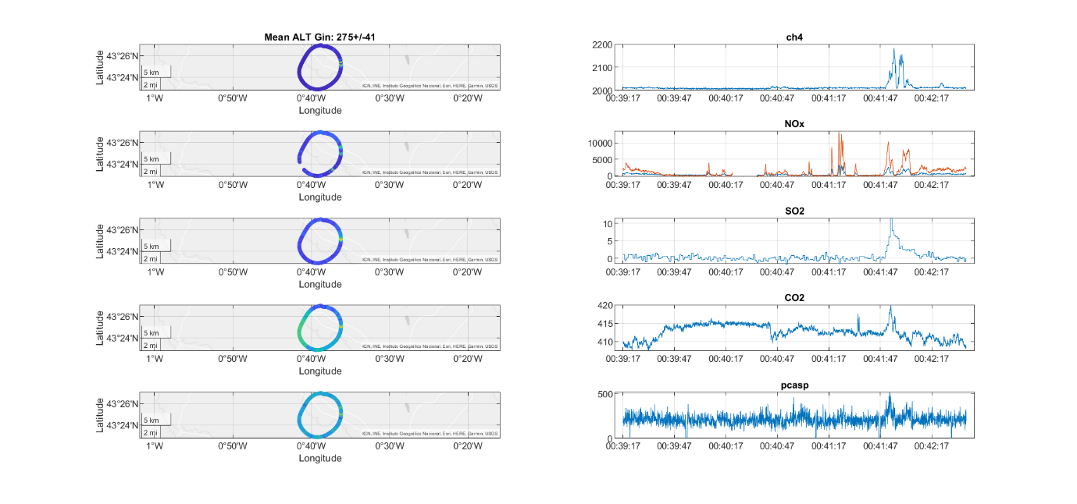
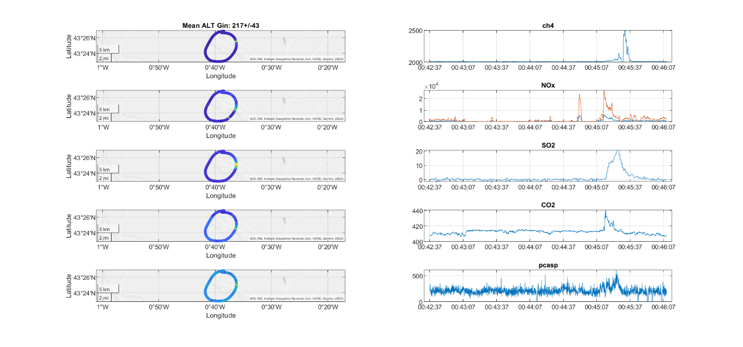
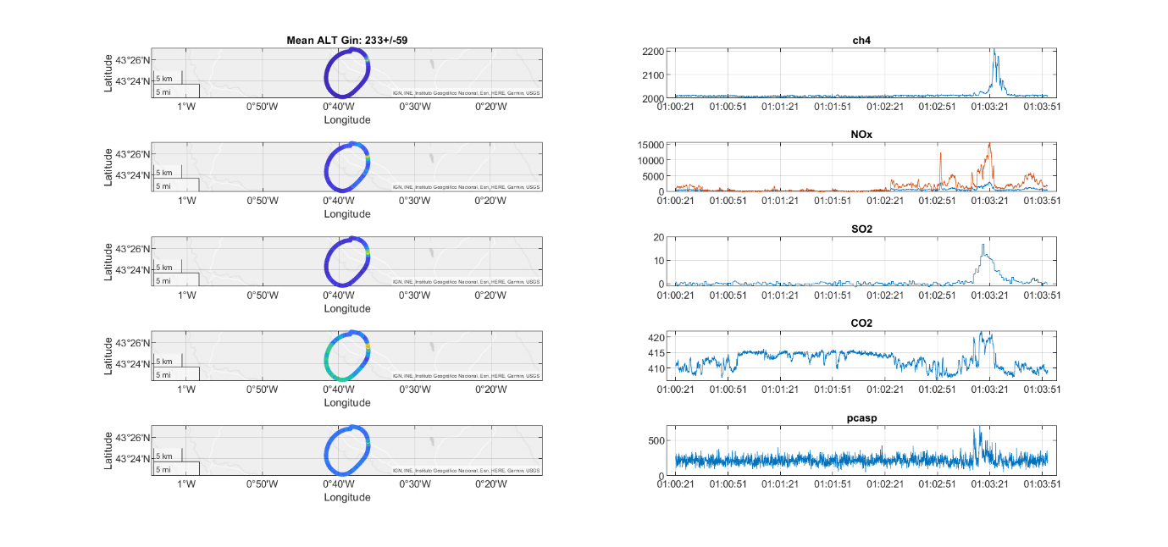

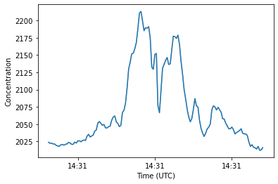
Example of CH₄ plume (10 Hz resolution) detected between 14:31:18.8 and 14:31:32.0 UTC at 191 m above ground level.

Further supporting evidence confirming the detected plumes origin

Discreet VOC measurements from whole air samples (sWAS pressurised canisters) did not reveal significant ethane enhancements in the detected plumes, with ethane concentrations between 1 and 2 ppb.
Of the 8 Tedlar bags collected for detected plumes during controlled release #7, 4 yielded sufficient CH₄ enhancements above background concentrations to allow for Keeling plot calculations, with δ¹³C_{CH4} isotopic signature ranging -40.77 to -45.68‰. These values compare to -41.81‰ for 2 high CH₄ concentration samples collected on the ground near TADI releases by Royal Holloway personnel (2nd week in September) and provide further confidence that the correct fossil fuel release plumes were identified.

ADMS6 dispersion model initialisation parameters
Domain grid data
10 x 10 km centred on TADI-PPL, 10 m resolution in XY plane
50 to 450 m above ground levels, 11 vertical levels resolution in Z
French coordinate system for XY projection: RFG93 v1 Lambert-93 (epsg:2154)
Complex terrain model option selected. Created using IGN RGE ALTI 5 m resolution .asc 5 x 5 km tiles for “Département 64 - Pyrénées-Atlantiques” and ADMS6 Mapper tool to cover domain. Roughness map also selected and created with ADMS6 Mapper tool.

Single point source
Height = 4 m
Pipe diameter = 4”
Exit velocity = 80 m/s
Cp = 1012 J/°C/kg (pure methane)
Emission Rate = 100 g/s (nominal value)

Meteorology – assumed to be constant during release #7 (hourly averages)
Surface temperature = 16.85 °C estimated prior to take-off at Pau-Pyrénées airport (temperature measurement by FAAM). Note that this value compares to 15.5°C at the nearby Lagor meteorological station (14:00 UTC), https://www.aeris-data.fr/catalogue/?uuid=665029c8-82b8-4754-9ff4-d558e640b0ba
Wind Speed (specified for 200 m) = 2.12 m/s. 2.12±0.80 m/s is the mean wind speed for all orbits flown during release #7 between 150 and 450 m above ground level
Wind direction = 275.00°
Wind direction lateral spread = 10°
Cloud cover = 7 oktas
Boundary layer height = 850 m
Surface albedo = 0.23 (default)
The boundary layer height was estimated using the ascent profile started at 14:32:05 UTC. The following Tephigram suggests a feature at ~910 hPa (or 880 m above ground level). This is confirmed by the profile data for ozone and carbon dioxide.

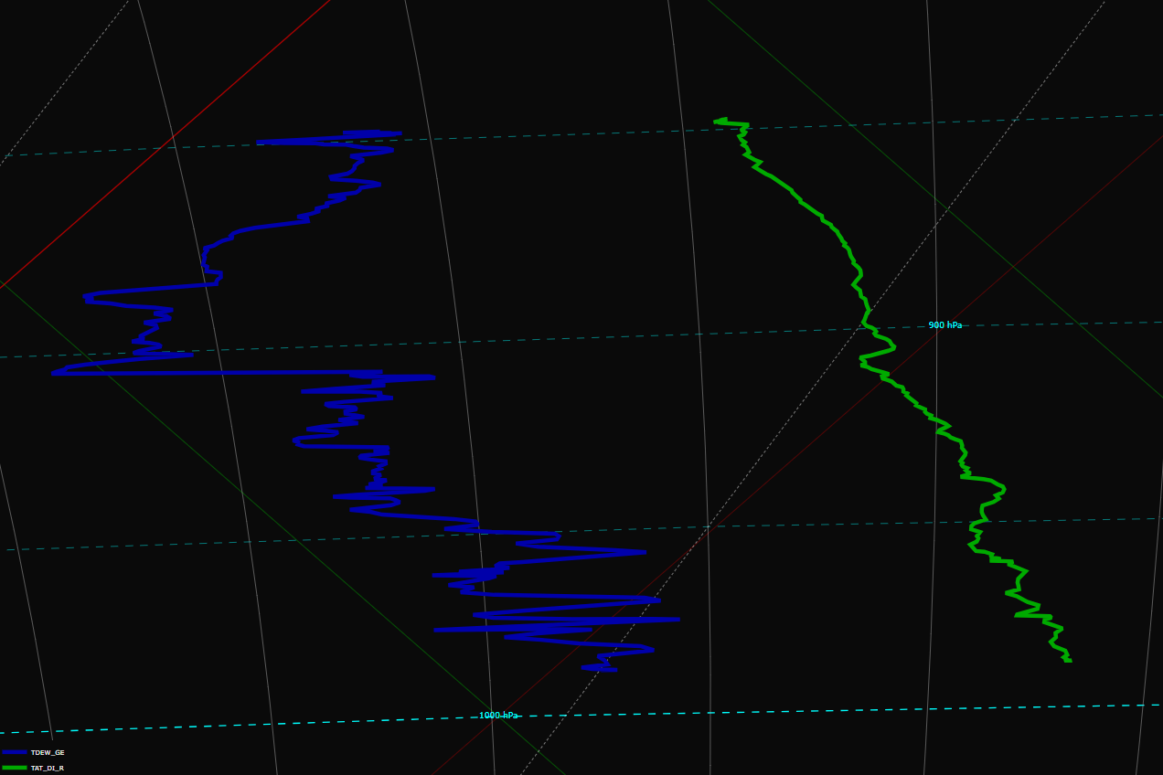
Tephigram showing General Eastern dew point and true air temperature during ascent profile P1 (14:32:05-14:36:18) from 150 to 1500 m above ground level
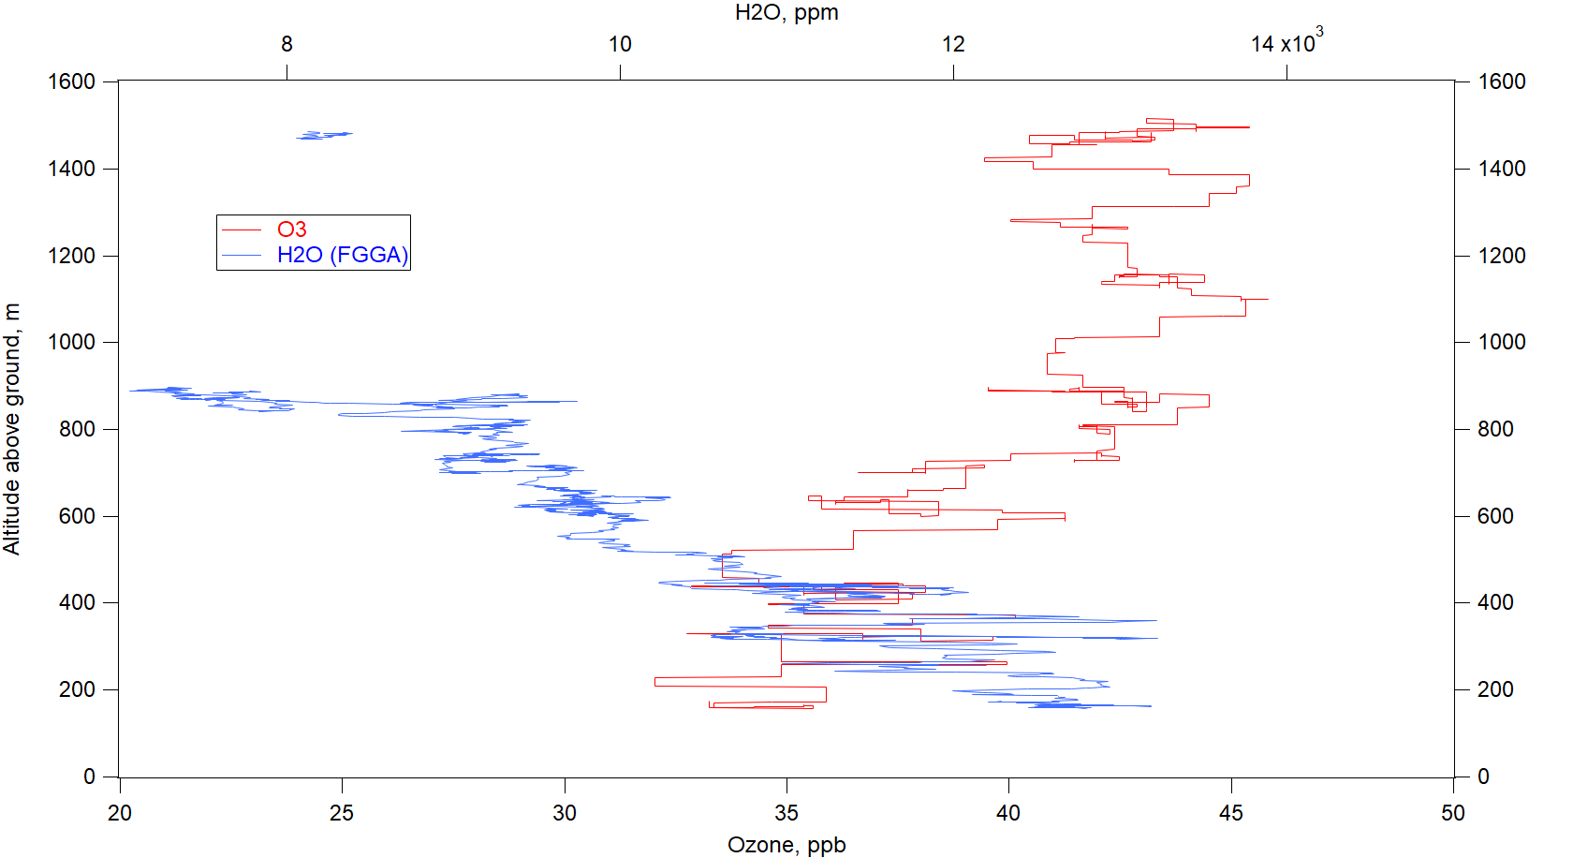
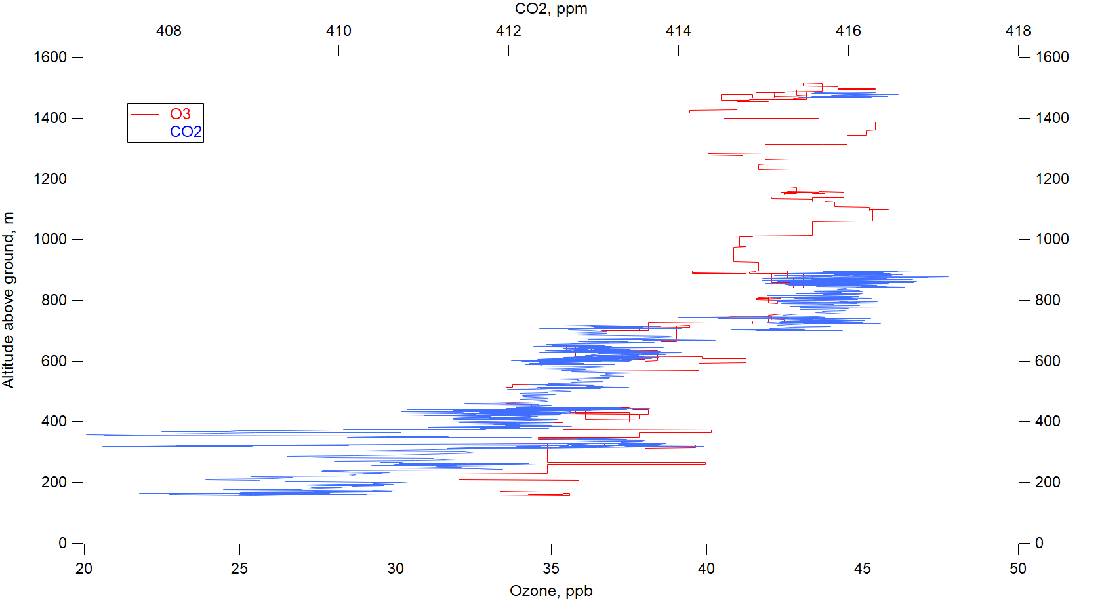
O₃ (ppb), H₂O (ppm) and CO₂ (ppm) as measured by the FAAM aircraft during ascent profile P1 (14:32:05-14:36:18) from 150 to 1500 m above ground level. The H₂O and CO₂ data gap correspond to an in-flight calibration triggered inadvertently by the operator before the end of the profile

Emission rate quantification results

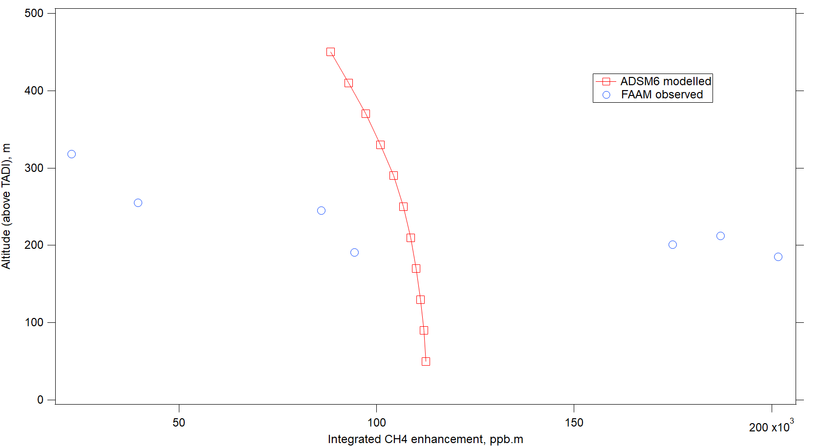
Integrated CH₄ enhancements (ppb.m) from 7 plumes detected during controlled release #7 (blue circles) and corresponding ADMS6 modelled enhancements at 11 vertical levels along the orbits flight track (red squares)

Start time | Stop time | Altitude above TADI | Observed integrated CH₄ enhancement | ADMS modelled integrated CH₄ enhancement | Emission rate | Emission rate
UTC | UTC | m | ppb.m | ppb.m | g/s | kg/hr
14:09:51 | 14:10:07 | 245 | 86093 | 107031 | 80.4 | 290
14:13:31 | 14:13:39 | 201 | 175010 | 108973 | 160.6 | 578
14:16:49 | 14:17:01 | 185 | 201676 | 109580 | 184.0 | 663
14:20:44 | 14:20:53 | 212 | 187086 | 108487 | 172.5 | 621
14:24:19 | 14:24:27 | 255 | 39711 | 106546 | 37.3 | 134
14:27:20 | 14:27:53 | 318 | 22832 | 102056 | 22.4 | 81
14:31:19 | 14:31:32 | 191 | 94489 | 109337 | 86.4 | 311
 |  |  |  | mean | 84.0 | 302
 |  |  |  | sdev | 61.2 | 220

Although 19 orbits were performed during controlled release #7 between 13:30 and 14:30 UTC, only the last 7 orbits produced well defined plumes assumed to be within a “stabilised regime”. The above table summarises the observed and corresponding modelled integrated CH₄ enhancements (ppb.m) used to derive emission rates.

